INSTRUCTIONS FOR UMEMA 2015 WORKSHOP
J. Lagrange¹, P.-S. Laplace², B. Pascal³
¹Laboratory1, mail1 e-mail1
²Company2, mail2, e-mail2
³Institution3, mail3, e-mail3

Abstract. This document stands for a guideline for a proposal in the workshop Uncertainty Modeling for ElectroMagnetic Applications (UMEMA 2015) which will take place in Saint-Nectaire (Auvergne country, France) from June 29th to July 1st 2015. This document may be used freely (template). No more than 150 words will be used in the abstract. A particular care is expected from authors for this abstract since it will be given to the symposium participants. The authors will submit the abstract (PDF) via the workshop contact e-mail (see instructions on the website).

LANGUAGES
The preferred language for articles are English and French.

CONTENT
The originality and technical content are the most influential elements assessed by reviewers. The clarity and the match with symposium topics will be assessed.

Présentation

Pages number
Abstract: maximum 2 pages.

Page layout
Please adjust your word processor to print PDF with A4 format (21 cm x 29.7 cm), see Table 1. for margins.
The title must be located at 3 cm from top of the page and the text may begin at least one blank line after authors' information. The width of one column is 8.2 cm with a 0.6 cm space between two columns.

Table 1. Margin
Size | Top | Bottom
A4 | 3.0 cm | 2.5 cm
 | Left | Right
A4 | 2 cm | 2 cm

Formatting

Fonts
Use font Time New Roman or similar fonts with a simple line space. The preferred sizes and styles are given in Table 2.
Table 2. Sizes of fonts and list of styles
 | Size | Style | Case
Title | 14 pts. | Bold | Upper
Authors' names | 12 pts. | Bold | Lower
Institution | 10 pts. | Normal | Lower
Abstract | 10 pts. | Normal | Lower
Text | 10 pts. | Normal | Lower
Title l | 10 pts. | Bold | Upper
Title 2 | 10 pts. | Bold | Lower
Title 3 | 10 pts. | Italic | Lower
Equation | 10 pts. | Normal | Lower
Legend Fig., Table | 10 pts. | Italic | Lower
Table | 10 pts. | Normal | Lower
Reference | 10 pts. | Normal+Italic | Lower

Style
The styles of the article are given successively by Title 1, Authors then Institutions. For the text, the default style is Normal. The Word styles are given as follows:
- Title 1 to 4: the “title 1” is the article title, the levels 2 to 4 stand for the paragraph titles. The respective numbering is: I, I.1., a -.
- Normal: style for the text of the paragraph, simple line space.
- List: this list.
- Equation: 6pt spacing is defined for equations before and after them.
- Legend: The “Legend” style defines the captions for tables, figures, pictures and schemes. An automated numbering is given for tables and a different one for figures, pictures and schemes.
- Reference_puce: inserting references at the end of the article with an automated numbering..

Paragraph
For each proposed style, the line spacing between paragraphs is defined, then there is no need to add blank lines (see template). The paragraphs inside text must be defined without line space.

Pages numbering
Do not include any pages numbering.

Justification, Indentation
The two columns must be justified on the two sides. Always begin the text from the left margin (no indentation). The equations may begin with a 1cm left margin. The title, the authors' names and their information may be centred.

Symbols
The symbols and acronyms must be clearly written and defined when they appear the first time in text. Use the international system of units (I.S.U.).

Equations
The equations must be numbered with parenthesis and a right justification (see following example). The size of variables is 10 pts (similarly to text).
$L\frac{∂I}{∂t}+\frac{∂V}{∂x}=0$ ()

Figures, Tables, Curves and Pictures
The figures, pictures, tables and graphs must be numbered and their references may appear in the text. The oversized figures or tables may be located over the two columns if necessary. Do not frame the figures.
The captions have to be placed and centred below the figures, pictures.
Be careful to the readability of labels, especially for graphs.
The pictures will be reproduced correctly in the electronic proceedings, but they will not be published in colour in paper version.
Avoid use of JPG files for curves (TIFF and EPS are recommended). The authors may ensure a sufficient resolution when preparing their PDF.
Please check the quality of the PDF version before submitting.

Curves
The units (x- and y-labels) must be expressed in the figure with units and symbols (see Fig. 1).

Pictures
The black & white pictures are preferred for printing purposes.

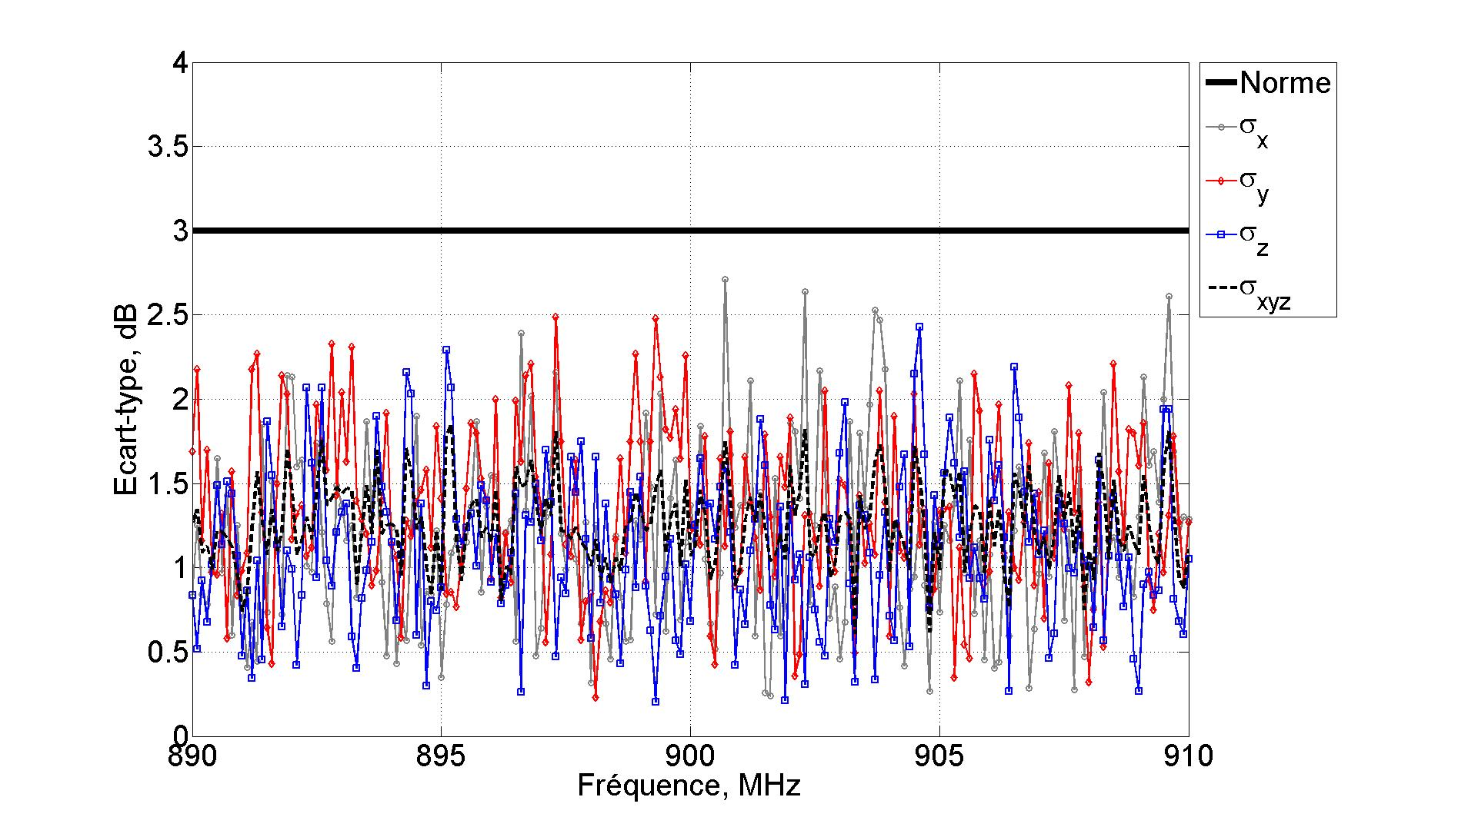
Fig. 1. Curve example.
REFERENCES
- C. R. Paul, "Introduction to Electromagnetic Com-patibility", John Wiley & Sons, Inc., New York, 1992.
- V. A. Rakov and M. A. Uman, "Review and eval-uation of lightning return stroke models including some aspects of their application", IEEE Trans. on Electromagnetic Compatibility, Vol. 40, n°4, pp. 403-426, November 1998.
The references will be given in the text using square brackets [1]. The references list is detailed in the end of the text following the above example.

SENDING YOUR PROPOSAL
The communications will be submitted via PDF files based upon the e-mail given on website:
http://umema2015.univ-bpclermont.fr

For all questions and/or remarks about the website and the abstract writing, please feel free to contact:
umema2015@univ-bpclermont.fr

Deadlines:
- Two pages abstract: by the end of March 2015,
- Final registration: May 2015.

